

















Parent Information Booklet
BELIEVE ACHIEVE SUCCEED

WELCOME TO WODENSBOROUGH ORMISTON ACADEMY

Thank you for choosing Wodensborough Ormiston Academy as the Secondary Education provider for your child.

We are aware that this transition can be an unsettling time for both you and your child and hope that this booklet will help by giving you all the basic information you require and answer some of your questions.

The first section of the booklet deals with the more formal information you may need. At the end of the booklet is a section that contains some answers to frequently asked questions. This list is not exhaustive. We hope that by working in partnership with you over the next five years we can make your child’s experience at Wodensborough Ormiston Academy happy and rewarding, allowing them to fulfil their true potential.

If you do not follow our Facebook page please do take the opportunity to. We post details of a variety of events from our School calendar to ensure that you do not miss anything important on a regular basis.

https://www.facebook.com/wodensborough
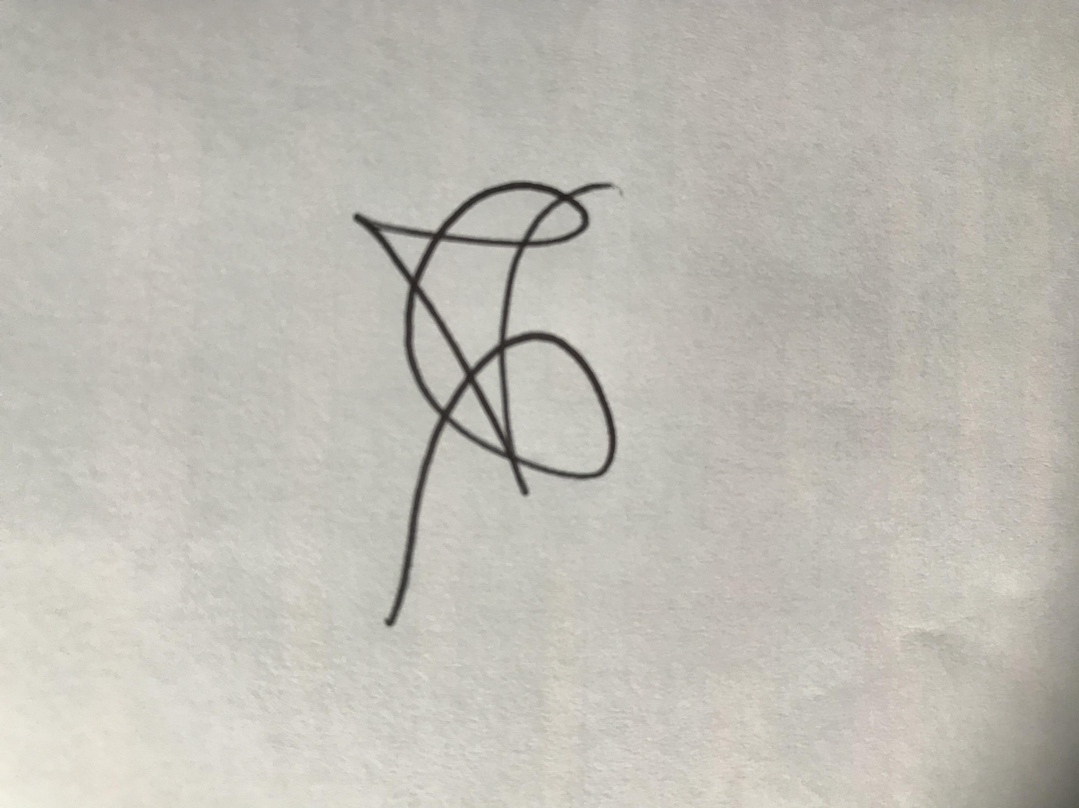

Ms L Moore
Principal

This booklet contains information about:

- Useful Contact Names and Numbers
- Times of the Academy Day/Key Dates
- Academy Uniform Requirements
- Equipment List
- Grouping Arrangements
- Homework
- Your Support as a Parent
We will do all we can to make the transition from Primary School to Secondary School a positive experience.

We look forward to working in partnership with you.

USEFUL NAMES

There might be questions that you would like to ask, but you do not know who to approach. There are people who can help.

Year 7 are managed by our Lower School Team

The Head of Year 7 is Mr Webster
The Pastoral Manager for Year 7 is Ms White

Your child will be placed in a Tutor Group of approximately 30 children from a mix of different Primary Schools.

The Tutor is the person who has contact every day with your child. He/she registers your child, is in contact with staff that teach your child and is the first person you must contact should your child experience difficulties or you have any other queries or issues you want to discuss.

The Special Educational Needs & Disability Co-Ordinator is Ms Locke
The Academy will offer support to students who experience problems with learning and in managing their behaviour. Support strategies include:
- Mentoring
- Counselling
- Outside agency support
- In class support
- Withdrawn groups
- Nurture groups

The Academy will do their best at all times to support students and their parents when problems arise. The success and wellbeing of every child matters to us.

Please be aware that all of the above staff have teaching commitments. Therefore, you will need to ring the academy and make an appointment should you require a meeting.

Pastoral Managers make daily contact with Tutors and make sure your child is working hard, behaving as well as we expect them to and settling into Academy life. They will be available for you to speak if you or your child has any worries or concerns.

USEFUL CONTACTS

If you need to speak to any member of staff please contact the Academy alternatively please find below some useful email addresses:

Address: Hydes Road
Wednesbury
WS10 0DR

Telephone: 0121 506 4300

Email: info@woacademy.co.uk

Contact Names
Principal: Ms L Moore

Vice Principal: Mr M Wagstaff
Vice Principal Mr S Bowler

Senior Assistant Principal Mr C Smith
Assistant Principal Miss N Atkins
Associate Assistant Principal Mr P Harris
Associate Assistant Principal Mrs C Jones
Associate Assistant Principal Mr D Martin
SENDCo Miss J Locke

Head of Year 7
Mr K Webster karl.webster@woacademy.co.uk

Pastoral Manager
Ms T White tracey.white@woacademy.co.uk

Your main points of contact in school will be your child’s Tutor, Pastoral Manager or Head of Year. These key people will be responsible for the pastoral care, wellbeing and the academic progress of your child.

ACADEMY DAY

 | From | To
SMART START | 8.45am | 9.15am
Lesson 1 | 9.15am | 10.15am
Lesson 2 | 10.15am | 11.15am
BREAK | 11.15am | 11.35am
Lesson 3 | 11.35am | 12.35pm
Lesson 4 | 12.35pm | 1.25pm
LUNCH | 1.25pm | 2.15pm
Lesson 5 | 2.15pm | 3.15pm

Smart Start is your daily tutor time where your child will receive Personal, Social, Health and Moral Education, additional work for literacy and numeracy, as well as advice and guidance on things such as careers and E-safety.

BREAKFAST CLUB
The canteen is open for breakfast and study support from 8.15am till 8.40am each morning. Toast is also available from the Safeguarding Hub and Harrison.

BREAK TIME
The canteen is open at break time for you to buy hot snacks and drinks.

LUNCH TIME ARRANGEMENTS
All students are required to stay on the Academy premises during the lunch break.

Food can be purchased from the canteen and snack shack, or you can bring a packed lunch.

If you qualify for a free school meal you will have money allocated to your school account each day, after break. You as the parent/guardian can add money to your account from home.

TERM DATES

Autumn Term 2023

From: Monday 4th September
To: Friday 22nd December

Half Term Holidays:
Monday 30th October – Friday 3rd November

Christmas Holidays:
Monday 25th December 2023 – Friday 5th January 2024

Spring Term 2024

From: Monday 8th January 2024
To: Friday 22nd March

Half Term Holidays:
Monday 12th February – Friday 16th February

Easter Holidays:
Monday 25th March – Friday 5th April

Summer Term 2024

From: Monday 8th April
To: Tuesday 22nd July

May Day: Monday 6th May

Half Term Holidays (Whitsun):
Monday 27th May – Friday 31st May

Summer Holidays:
From: Wednesday 23rd July

Dates of Parents’ Evening, Training Days, and Year 7 Academy Reports will be notified to you at the beginning of the Academy year. The information will also be displayed on the Academy website and though our social media pages. These are subject to change.
ACADEMY UNIFORM REQUIREMENTS

At Wodensborough Ormiston Academy we have a uniform, which must be worn at all times.

Students are expected to bring a bag to carry books and equipment.

Boys
- All black shoes with black laces (No trainers)
- Heel height no greater than 25mm (1”).
- Black standard trousers
- Black blazer with school logo (Compulsory)
- Black jumper with royal blue and yellow stripe and school logo (optional)
- Plain white shirt long or short sleeved
- Academy tie
- Dark plain socks
- A bag for equipment
Girls
- All black shoes. (No trainers)
- Heel height no greater than 25mm (1”)
- Black blazer with school logo (Compulsory)
- White or dark plain socks or plain opaque tights
- Black full length trousers (black belt if required) or black skirt – must be knee length or longer, no leggings.
- Plain white blouse long or short sleeved
- Black jumper with royal blue and yellow stripe and school logo (optional)
- Academy tie
- A bag for equipment

We expect all students to wear their Academy blazer everyday. The Academy jumper may be worn underneath during colder weather.

The wearing of ‘hoodies’, coats or other non-regulation sweaters, is NOT acceptable.

SPORTS KIT

Here are details of the clothing that must be worn in P.E. lessons:

P.E. Kit

All students must wear the official P.E. Kit. This includes:-

- Wodensborough shorts or tracksuit bottoms (including the correct academy socks if shorts are worn).
- Wodensborough polo neck T-shirt or hoodie.
- Suitable footwear with tied laces.

All of the above items of schoolwear and sports kit are available from:
GOGNA Schoolwear
Junction Two Industrial Estate
Unit 1B, Demuth Way
Oldbury
B69 4LT
Tel: 0121 523 5572
www.gognaschoolwear.co.uk
email: sales@gogna.me

We will also be hosting a uniform sale day in school over the Summer Holidays on the following date:

Friday 4th August 10am – 2pm

If in any doubt on any aspect of uniform, please consult the academy before purchasing.

RULES REGARDING APPEARANCE

- Please ensure that all uniform and Sports kit is clearly marked with the student’s name.

- Trainers are NOT to be worn in the academy other than during P.E./Performing Arts lessons.

- The ONLY jewellery allowed is one pair of sleepers or studs and a watch. These must be removed for P.E. and Dance lessons. For health and safety reasons facial piercings are NOT to be worn at the academy

- Extreme hair colours or nail polish are NOT allowed.

- Fashion items such as belts, scarves, caps, brightly coloured hair accessories and sunglasses are NOT to be brought into the academy.

- Outdoor coats should NOT be worn inside classrooms.

- Headphones should not be brought into the academy.

THE FOLLOWING ITEMS OF PROPERTY ARE NOT ALLOWED IN THE ACADEMY:

- Personal audio equipment (Ipods,etc)
- Weapons of any description
- Laser pens
- Computer games and consoles
- Matches/lighters.

MOBILE PHONES

Mobile phones, MP3 players or any similar devices cannot be used in any part of the Academy site. Students bringing phones to the Academy must turn them off at the Academy gates and keep them out of sight.

Students seen with any such devices or headphones will have them confiscated until the end of the day.

The school cannot accept responsibility for mobile phones or valuable items brought into the academy. If a student is seen with a phone, it will be confiscated and can be collected from the school office at 3.10pm

FIZZY/ENERGY DRINKS
These are not allowed to be brought to the Academy

EQUIPMENT LIST

BASIC

In addition to academy uniform, students need to be equipped for lessons. Here is a list of standard items all students should have:

- School bag
- Pencil case
- 2 writing pens (blue or black)
- 2 responding to marking pens (green)
- 2 pencils
- Rubber
- Ruler (at least 15cms long)

SPECIALIST EQUIPMENT
Some lessons require students to have specialist equipment:

- P.E. Kit detailed in Uniform Section
- Trainers for P.E and Performing Arts Only

ILLNESS, ACCIDENT OR MEDICAL ISSUES

The Academy has procedures in place to deal with illness (short term and long term) and also incidents that require medical attention.
We work with parents/carers in a number of ways to ensure that the students well-being is given the highest priority.

Long Term Medical Issues
We require information from parents/carers about any medical issues that your child has, particularly if the issue is likely to impact on academy life. Records are maintained by the Medical Officer, Head of Year or SENDCO relating to the information given to us. Where appropriate, staff will be informed about the condition. We will respect confidentiality of any medical information given to us when requested unless there is a serious implication for others. In this case, we will meet with parents before any information is disclosed.

Student Illness
If a student is taken ill during the academy day, the Head of Year will assess the situation and inform our Medical Officer if necessary. If we feel the student is able to continue in the academy, we will encourage that and support the student as necessary. If there is any doubt about the student’s ability to continue, we will contact parents. Please note that students should not contact parents themselves but should always report to the Year 7 School Office. Where students have a medical condition which does NOT prevent them from attending the academy but does require some measure of medical input during the academy day, the Medical Officer and Head of Year must be informed so that a care plan can be put in place.

Medication
Students who require any medication should request that their GP or Consultant prescribe medication that can be taken out of the academy hours whenever possible. If this is not possible, the academy can store prescribed medication for students (including medication that has to be kept in a fridge). A written request must accompany the medication which should also be clearly labelled with the student’s name and details of the required dosage. 5ml spoons, where required, should be provided by the parent/carer. Staff will generally NOT supervise the taking of medication nor administer it. However, in exceptional circumstances this may be arranged by contacting the academy. A written request will also be required. Note that we cannot store non-prescription medication nor do we issue medication such as paracetamol or aspirin.

Accidents
In the case of an injury to a student, we have a team of trained First Aiders. They will make an assessment, administer First Aid as appropriate and contact parents. In the case of a serious injury, the academy will seek assistance from the medical professionals e.g. Ambulance. Parents will be contacted immediately.

HEALTHY EATING

We are keen to support Government initiatives to encourage students to live a healthy lifestyle. Your child, on average, will spend a quarter of his/her life in secondary education and we recognise that this is a big step from Primary School. Poor diet is a major contributor to lack of concentration, dehydration and poor behaviour.

We would therefore encourage you to make sure that your child has breakfast each morning and brings a bottle of water to the academy.

It may take your child a little time to adjust to the later lunchtime, but our experience is that students quickly adapt to the new time.

FREE SCHOOLS MEALS

Do you receive any of the following?
- Income Support
- Universal Credit – with a household net income of less than £7,400 a year
- Job Seekers Allowance – Income Based Only
- Employment & Support Allowance – Income Related Only
- Pension Credit – Guaranteed Element (including Child Tax Credit)
- Support under Part VI of the immigration and Asylum Act 1999
- Child Tax Credit only – with an annual income of less than £16,190
(NOT including Working Tax Credit - check your latest Tax Credit Awards Notice if you are unsure)
- Working Tax Credit run-on (paid for the four weeks after you stop qualifying for Working Tax Credit)
If you have answered yes, your child may be entitled to Free School meals. You can make an application online at the Sandwell council website.

If you receive Working Tax Credit regardless of annual household income you will not qualify for Free School Meals.
The Academy relies on funding from Free School Meals therefore we urge you to please apply for them whether your child wishes to take a meal or not.
If you require any further information please contact the Academy on 0121 506 4300.

GROUPING ARRANGEMENTS

Academic Groupings

Subjects will be taught in two different grouping arrangements, after initially being placed in one of two parallel bands Believe band and Achieve band. A smaller number of students who need additional support may be placed in the Succeed band. Students will then be arranged in sets according to ability for core disciplines such as English, Maths and Science, whereas in subjects such as ICT, Arts, Technology and PE students are taught in a variety of different grouping arrangements according to the requirements of the subjects.

More Able, Gifted and Talented Students at WOA
WOA is committed to raising aspirations and standards for every single one of our students, including the most able.

Our More Able, Gifted and Talented Students are identified early on in their journey here; we use their prior attainment data and identify our "Shine" Students, typically the top 5% in each year. Staff from all curriculum areas nominate students who are gifted and talented in their subject areas.

The progress of our More Able, Gifted and Talented is carefully monitored and reviewed, so that appropriate interventions to support or stretch and challenge them may be put in place. Pace and challenge, alongside differentiated learning are key features of all lessons and most subjects group according to ability.

The Academy provides a vast range of extra-curricular opportunities for all our students to get involved in, from visits to top universities, online learning in small groups, inspirational trips and so much more!



Learning Routines

These are the classroom routines that all students and staff follow in every lesson across the academy. They enable quality teaching and learning to take place and help the students get used to what is expected of them during their lessons. Each symbol represents a different expectation.

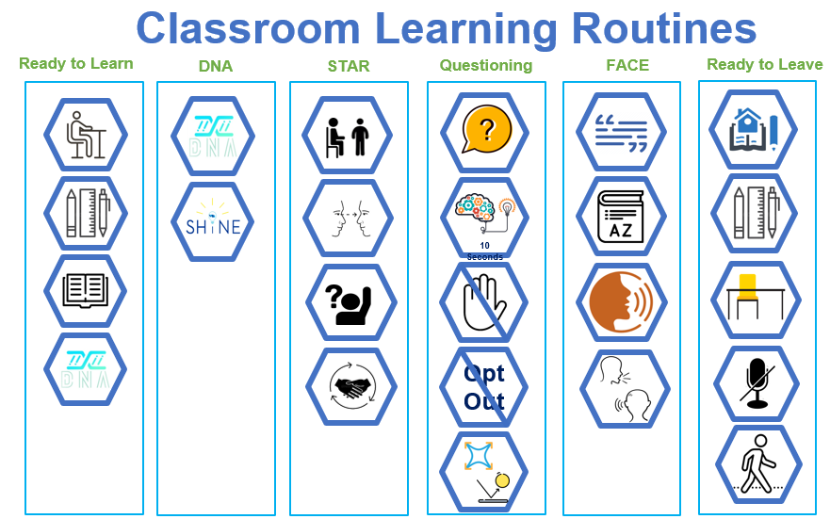

These routines also promote learning independence as students quickly learn what is expected of them and begin to self-regulate giving more time to the important stretch and challenge work mentioned earlier.

Attendance - #AttendToAchieve

Miss J Cooper is our Senior Leader for Attendance. Miss Cooper and her team, Miss Howen and Ms Moulton, our Home Liaison Officer, are your first port of call for attendance matters. Each day phone calls are made, and home visits are carried out by the team, to families when students are absent from the Academy for any reason.

Excellent attendance is the basis for a happy and successful school career, and this excellent attendance is directly linked to higher achievement.
It is essential that we work together to ensure your child attends every day. If there are unavoidable absences due to illness, bereavement, or medical appointments, please speak to the attendance office who can discuss this with you.

If you have any concerns that are preventing your child from attending, please contact the pastoral team who have a strong network of staff working with them to support you.

We are proud of our attendance here at WOA and we have worked hard to ensure all students attend school all day, every day. Should there be an unavoidable absence, parents are asked to telephone the attendance office before 8am on each day of absence.

Parents of students for whom attendance is a concern can expect regular communication from WOA. This is so that we can offer support to ensure improvements are seen. In rare cases where improvement in attendance is not seen, we will work closely with the Local Authority Schools Attendance Support Service, who may intervene, which ultimately may result in parents receiving a fine.

By working together, we can ensure that your child receives the best education available to them by ensuring they attend school, all day, every day.

We monitor attendance rigorously:

100% Gold Standard Attendance Award

97% > 99.9% Silver Standard Attendance Award

95% > 96.9% Bronze Standard Attendance Award

92% > 94.9% Of concern and will trigger intervention to support students and families

90% > 91.9% Poor – May result in Local authority attendance referrals

less than 90% Persistently Absent– Possible fines from Schools Attendance Support Service may occur

Attendance Rewards

Each week Ms Moore does a live broadcast to all students to reveal our Wheel of Wonder winners. Prizes can include Amazon vouchers, Just Eat vouchers, Amazon echo products or shopping vouchers. To be in with a chance to win, your child needs to attend the academy EVERY DAY AND ON TIME. Following the Wheel of Wonder, the weekly winner of most improved year group attendance is announced, and they are all invited to collect a treat from Ms Moore. These treats can include doughnuts or ice lollies.

Alongside our weekly recognition of excellent attendance, we also reward students for half termly attendance where Bronze, Silver and Gold Standard award letters are sent home to parents and carers and novelty gifts are given out at the prize shack by Ms Moore and Mr Wagstaff for excellent attendance, punctuality and behaviour.

EXPECTATIONS

We have high expectations of behaviour and discipline, both of which are necessary to ensure quality teaching and an orderly community. In establishing a sense of responsibility among students we hope to keep behaviour problems to a minimum.

We will contact you if your child is giving us cause for concern and work with you to find a solution to the problem. Students are aware of the high standards we maintain at WOA and it may be necessary to detain at break or after academy hours individuals who deliberately disregard Academy expectations.

REWARDS
We believe students respond to positive encouragement and success. Every opportunity is taken to praise and to acknowledge and reward achievement. Students will have opportunities to be rewarded the following achievement points that will go towards rewards throughout the school year.

#Believe Points
Outstanding effort.
Positive contribution to lesson.
Supporting peers.
Head of Faculty Award.

#Achieve points
Outstanding Classwork.
Outstanding Homework.
Attempting Difficult/Challenging task.
Working Beyond Target.
Leading Learning.
#Succeed points
Extra-Curricular.
Community Contribution.
Supporting Whole School Events.
Session 6/Saturday School.

SANCTIONS

If the Head of Year is concerned about work or behaviour in lessons, students may be placed on report where teachers can record observations on a lesson-by-lesson basis. We will inform you if your child is placed on report.

We do have detention every day for persistent offenders, and you will be informed at least 24 hours in advance if it is necessary for your son/daughter to remain behind.

However, all teachers can detain your child on any night of the week for 20 minutes without notifying you.

Incidents of serious misbehaviour will warrant further sanctions.

These could include;
- Central Detention for 20 minutes at lunchtime.
- Faculty detention of 30 minutes
- Senior Leadership detention every day until 4pm.
- A period of time in the Reflection Room.
- External Isolation.
- Alternative provision.
- Fixed term exclusion.
- Permanent exclusion

YOUR ROLE AS A PARENT

In order for students to achieve their full potential, the Academy and parents must enter into a partnership that supports and enables progress and learning.

- Parents must ensure that students attend the Academy every day, unless prevented by illness. Ring the Academy before 9am on every day of absence
- When students return to the academy following an illness we need a note, stating the date and reasons for the absence, which should be given to the Tutor
- Parents should not make holiday arrangements during term time for their children. Under the Education (Pupil Registration) (Amendment) Regulations 2013 absence may not be Authorised unless: (a) An application has been made in advance to the Head teacher by a Parent/Carer with whom the pupil normally resides (lives with most of the time); and (b) The Head teacher, or a person Authorised by them, considers that Leave of Absence should be granted due to the exceptional circumstances relating to that application.
- Please ensure that your child leaves home in good time to arrive at the academy punctually. Lateness will be sanctioned, by being issued with a 20 minute detention at lunchtime
- Please ensure you respond to requests for updated contact numbers and other information, as this is vital in the case of an accident/emergency
- Students must be fully equipped and prepared for learning everyday
- Ensure your child wears the correct uniform at all times and be firm with children about the jewellery and make-up rules
- Please monitor your child’s homework timetable. This should encourage students to meet deadlines with work completed at home
- If you have concerns about independent learning tasks, please contact us
- Try to provide somewhere quiet for your child to complete independent tasks, away from distractions, like music and TV.
- If there are any changes in your circumstances at home likely to affect your son’s/daughter’s performance in the academy, please make us aware of them as soon as possible
- Inform us if information needs sending to more than one address (because adults with parental rights are living separately)
- In order to protect our students, we have a facility to record Court Orders confidentially. It is the responsibility of parents/guardians to keep us fully updated with details of the Court orders; we will try to act in accordance with them at all times

WHAT TO DO IF:

Your child is unable to take part in a PE and Dance lesson due to illness or injury

You should
- Write a note to the PE/Dance staff to be given in before the lesson

What if:

Your child is finding work at home difficult?

You should
- Contact the subject teacher by phone or make an appointment to speak to them

What if:

Your child feels he/she is being bullied?

You should
- Encourage your child to tell their Form Tutor, Pastoral Manager, a Teacher a Mentor or a Steward, if this is difficult for them; you can speak to someone on their behalf. Contact the academy as soon as possible, if we are made aware of a situation, we can work together to sort it out

What if:

Your child needs to leave the academy to attend an appointment?

You should
- Write a note to his/her Form Tutor. Your child then has to sign out at reception; they will be given a pass. Without this they could be challenged outside the academy by Attendance & Prosecution Officers

FOR YOUR NOTES

