Friday 14th May 2021

Key Dates for Parents

Dear Parent/Carer,

Thank you for your continued support over the summer term as we have successfully reintroduced students to face to face learning. Now things have begun to settle and we have a clearer picture of remainder of the school year we wanted to share with you some key dates for parents and students from our academic calendar to help you plan and prepare.

Date | Event
SUMMER TERM 1
Wednesday 26th May | Y7 and Y8 Parents Consultation evening (Virtual)
Friday 28th May | End of Half Term 3.10pm
SUMMER TERM 2
Monday 7th June | School Re-opens 8.45am
Wednesday 23rd June | Y9 & Y10 Parents Consultation Evening (Virtual)
Friday 25th June | Training Day (school closed)
Monday 28th June | Training Day (school closed)
Friday 9th July | Year 11 Prom
Friday 16th July | Sports Day
Monday 19th & Tuesday 20th July | Enrichment & Rewards Days
Wednesday 21st July | Training Day (school closed)

We do hope that you find this useful and we will of course update you of any changes.

Yours Sincerely
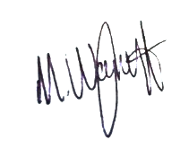
Leigh Moore Myk Wagstaff
Principal Vice Principal

